John Donne and other Metaphysical Poets

Before starting the presentation on this topic, it is really important to know about the concept of Metaphysical poetry.

The word ‘Metaphysical Poetry’ is a concept of philosophy used in literature where poets show the things that are beyond physical existence.

The word Metaphysical is a combination of two words ‘meta’ and ‘physical’. The first word “Meta” means beyond.

So metaphysical means beyond physical, beyond the normal and visibility. The meanings are clear here that it deals with the objects/ideas that are beyond the existence of this physical world. Metaphysical poetry started early in the last stage of the age of Shakespeare. John Donne was the leader and founder of the metaphysical school of poetry.

I think it is enough introduction to the Metaphysical Poetry. Now, can move to the next part of our presentation, that is related to the Metaphysical poets.

There are many personalities that took part into the metaphysical poetry. I will throw light on the work of some metaphysical poets and then in the last part of the presentation, I will explain the most prominent poet that is John Donne.

**Metaphysical Poets**

* **George Herbert**

George Herbert is known as the metaphysical poet and by honesty of his faith in God and religion. His poetry is a record of hard works, failures and victories in the practice of the Christian life.

In his poetry he argues with himself, with God and with other audience to show some religious reality of life.

* **Andrew Marvell**

Andrew Marvell is considered one of the metaphysical poets. Like John Donne, he wrote poems that are related to the metaphysical concepts, the fun and comparison that show the nature of metaphysical poetry.

Also, like Donne, many of his poems debate spiritual issues and the changing nature of life.

* **Abraham Cowley**

Abraham Cowley was born in London in 1968. He was a poet as well as an essay writer. He show his talent as a poet, publishing his first collection of poetry, Poetical Blossoms (1633), at the age of 15. His most famous work, the collection exemplifies Cowley's metaphysical style of love poetry.

* **Richard Crashaw**

Richard Crashaw was an English poet, teacher, High Church Anglican cleric and Roman Catholic convert, who was one of the major metaphysical poets in 17th-century English literature.

* **Henry Vaughan**

Henry Vaughan was a Welsh poet, and considered one of the “metaphysical poets” of 17th-century England. ... Vaughan's style was marked by an ingenious use of monosyllables in his verse, alliteration and, like most of the metaphysical poets of the time, a compelling use of elaborate imagery.

I think its enough, to talk about these poets and lets, move towards the most highlighted Poet of Metaphysics John Donne.

# John Donne

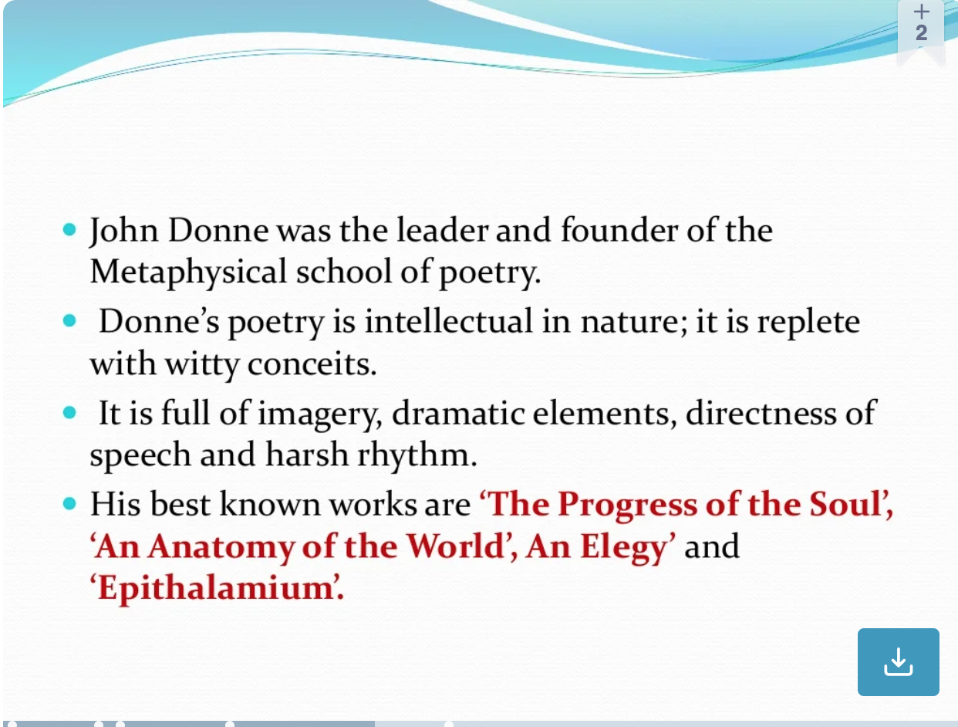

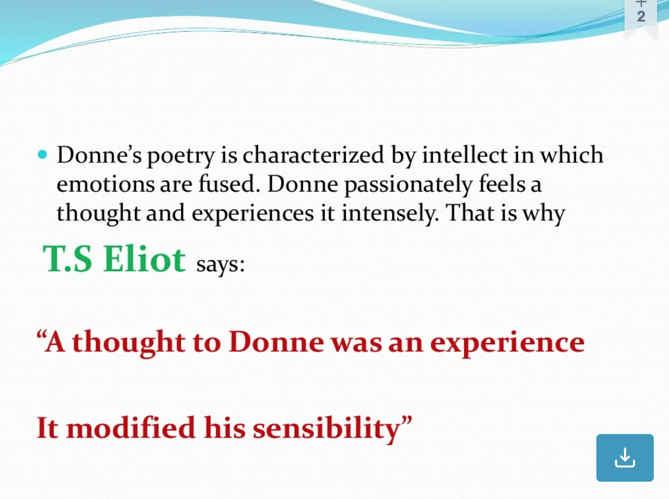

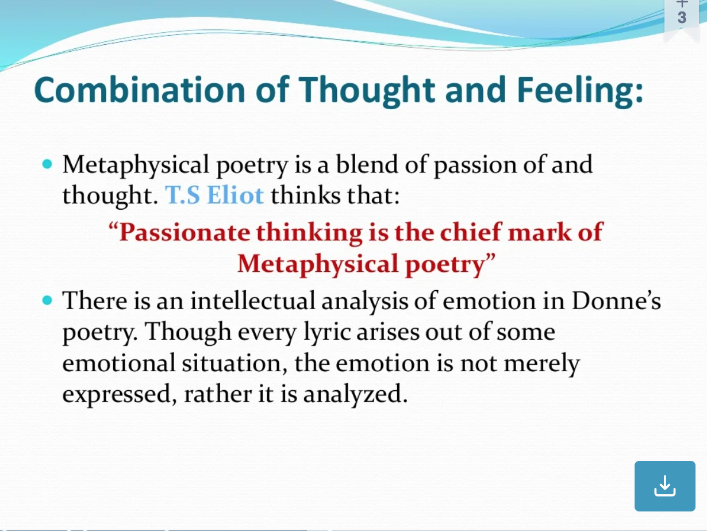

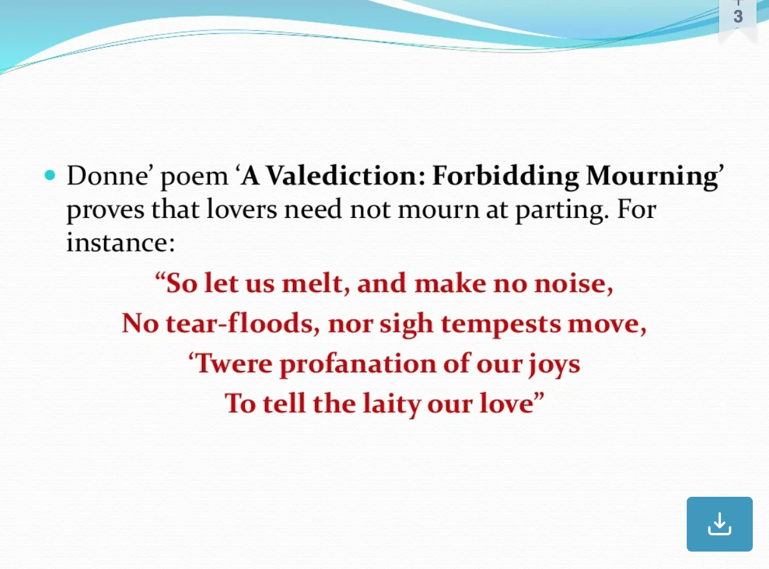

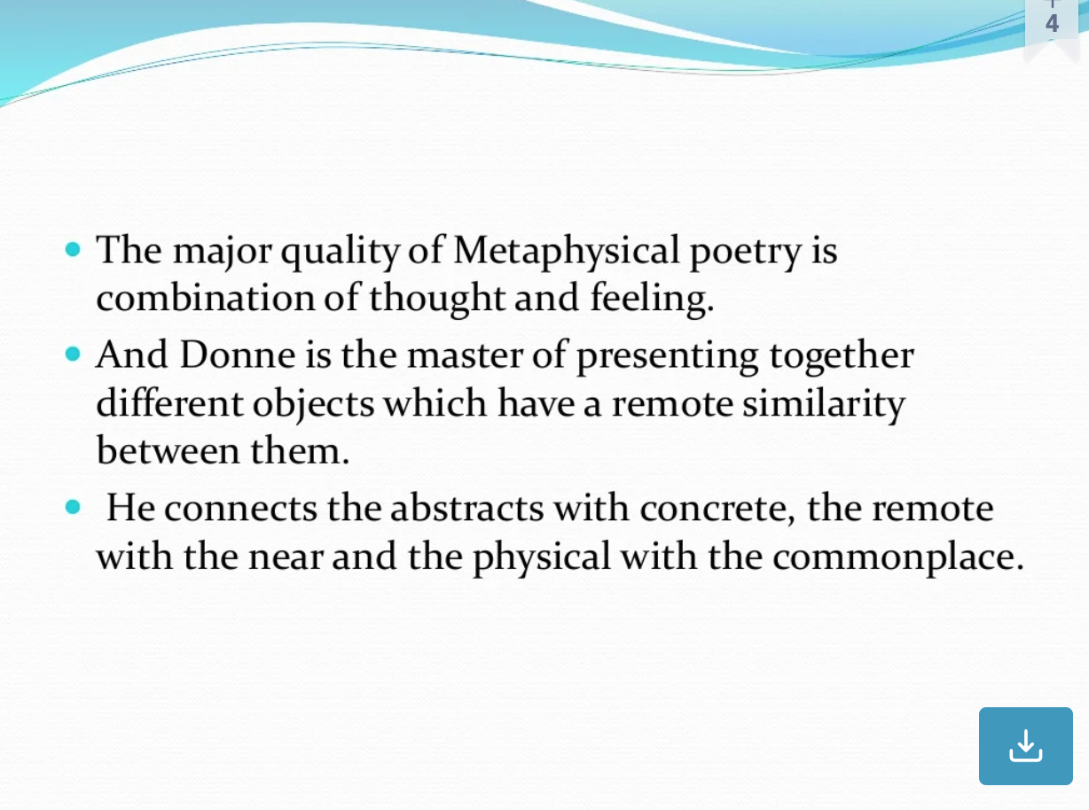

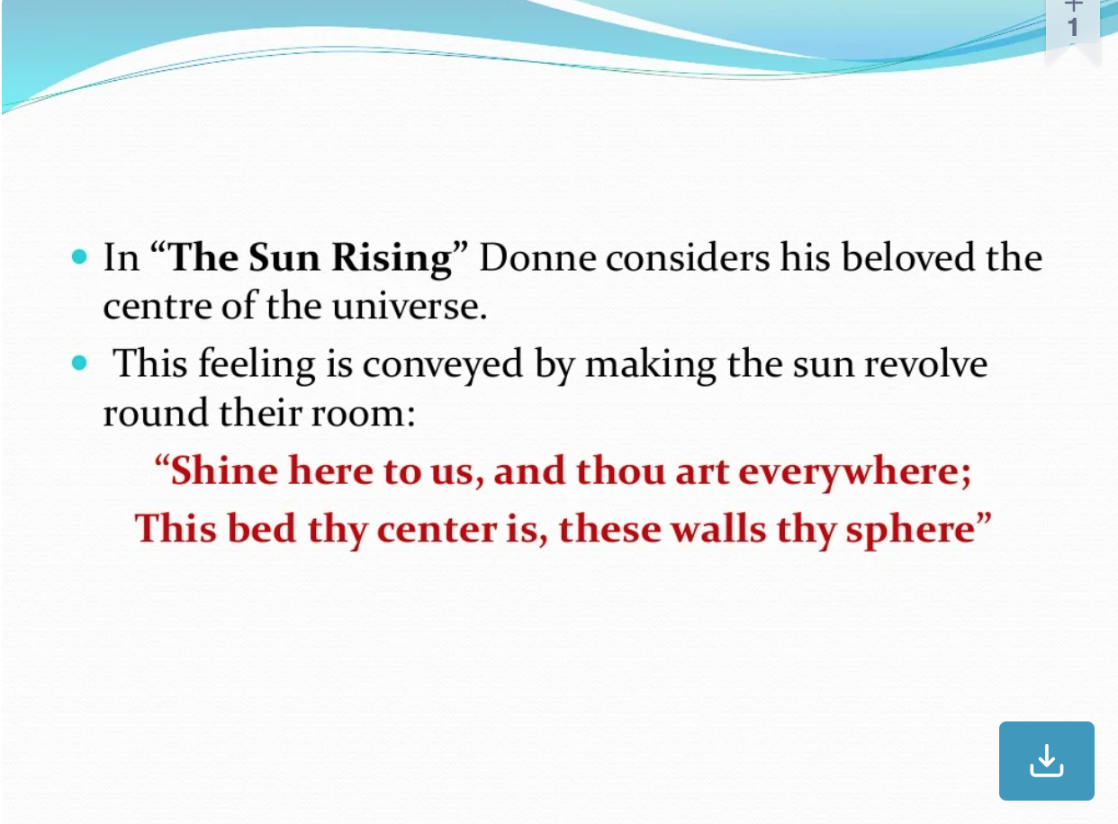

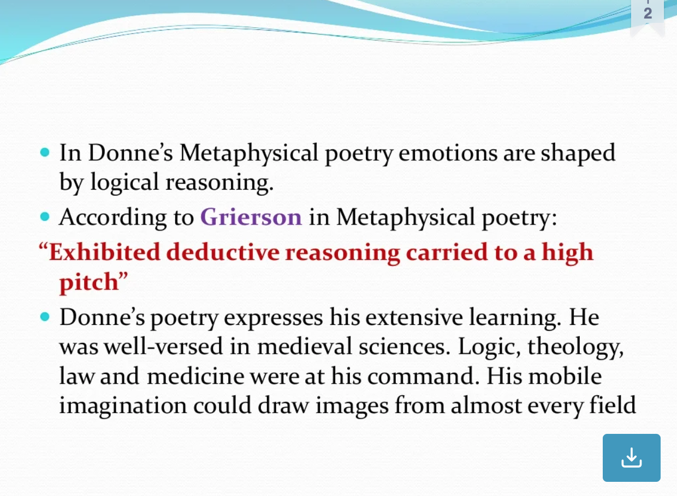

**Features of Metaphysical Poetry**

1. Metaphysical texts are based on wit and often deal with serious questions about the existence of God and the tendency of human beings to perceive this world.
2. In metaphysical poetry, serious issues are discussed with a touch of humor. In this sense, it makes the seriousness a bit light in intensity.
3. Metaphysical poetry elevates the readers of their normal existence to make them question the unquestionable.
4. Metaphysical texts offer comparisons of unlikely things and are loaded with conceits, paradoxes, irony, and
5. They are argumentative, intellectual, realistic and rational in their approach.